Docker Challenge-2
Goal of the Exercise
The goal of this exercise is to test your understanding of a Cloud Compute deployment with Terraform.
You are tasked with creating a codebase for a microservice deployment on a cloud environment, using Terraform. Since our focus is not the application itself, the service will be a simple web server that returns a static page.
Requirements
Service Details
The service will be a simple web server that returns a static page.
You can use apache2 or nginx to serve a simple HTML file.
The service should be containerized and stored in a Docker registry.
The service should be deployed on a single VM instance as a docker container.
The image should be pulled from the registry specified earlier.
- The service should not be accessible from the internet but only through a Load Balancer, except for SSH access from specific IP addresses.
Deliverables
You are to provide the following as part of your solution:
- Dockerfile to build the image.
Terraform codebase to deploy the following:
- Docker registry
- VPC and all required networking resources
- EC2 instance
- Load Balancer
Notes
Since a CI/CD pipeline is not part of this exercise, we will work around that with the help of Terraform.
To push the image to the Docker registry, build the image locally before running the Terraform code.
Once the image registry is created, use Terraform to push the local image to the registry.
Similarly, use Terraform to pull the image from the registry and run it on the VM instance once it is created.
For SSH access:
- Use a locally created key.
- Add it to the cloud provider key storage.
Attach it to the instance.
Use Terraform best practices for file structure and code organization.
Use variables, locals, modules, etc. when appropriate.
Include all tfvars, scripts, and other helper files used to deploy the application.
You may use any cloud provider of your choosing, although AWS is preferred.
STEPS:
  - Create Project Structure
mkdir terraform-microservice
cd terraform-microservice
mkdir app docker terraform scripts
  - Create Simple Web App
cd app
Create index.html:
<!DOCTYPE html>
<html>
<head>
<title>DevOps Challenge</title>
</head>
<body>
<h1>Hello from Terraform + Docker </h1>
</body>
</html>
  - Create Dockerfile
cd ../docker
vi Dockerfile
FROM nginx:latest
COPY ../app/index.html /usr/share/nginx/html/index.html
EXPOSE 80
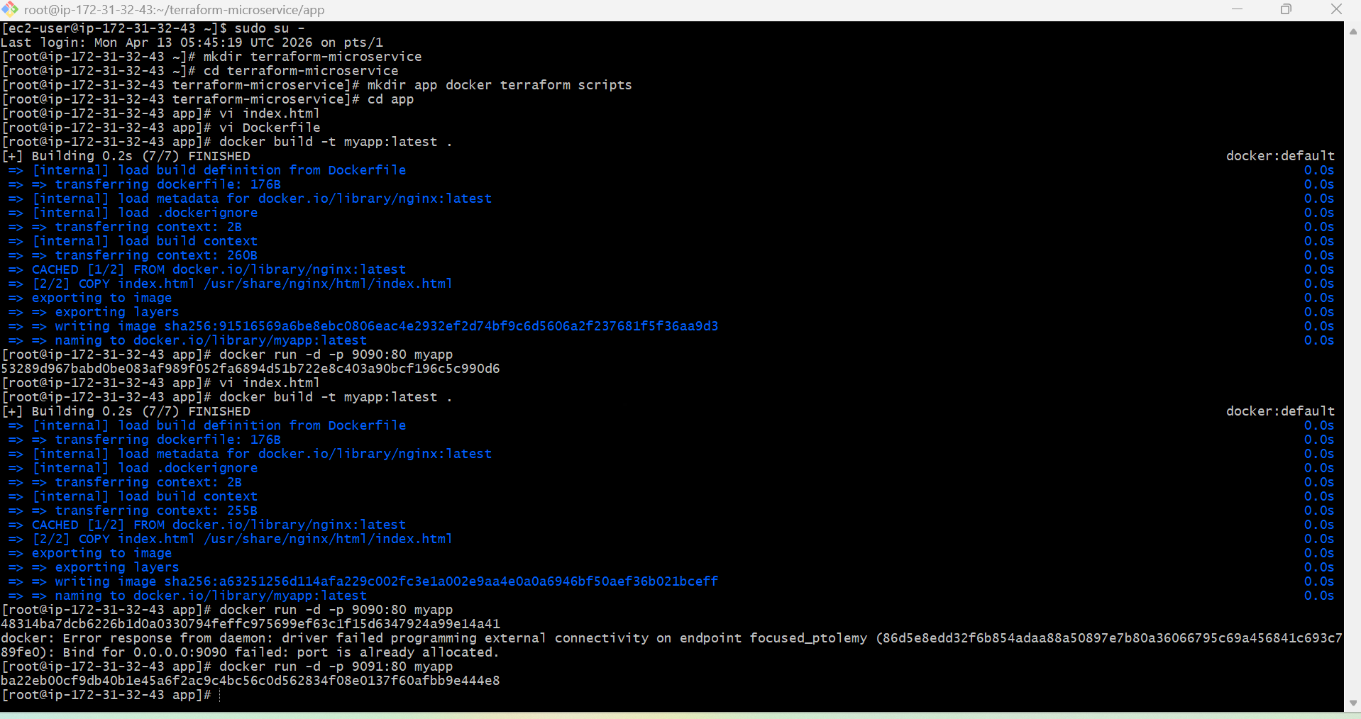

  - Build Docker Image (LOCAL)
docker build -t myapp:latest .
Test locally:
docker run -d -p 9091:80 myapp
Open: http://13.60.225.49:9091

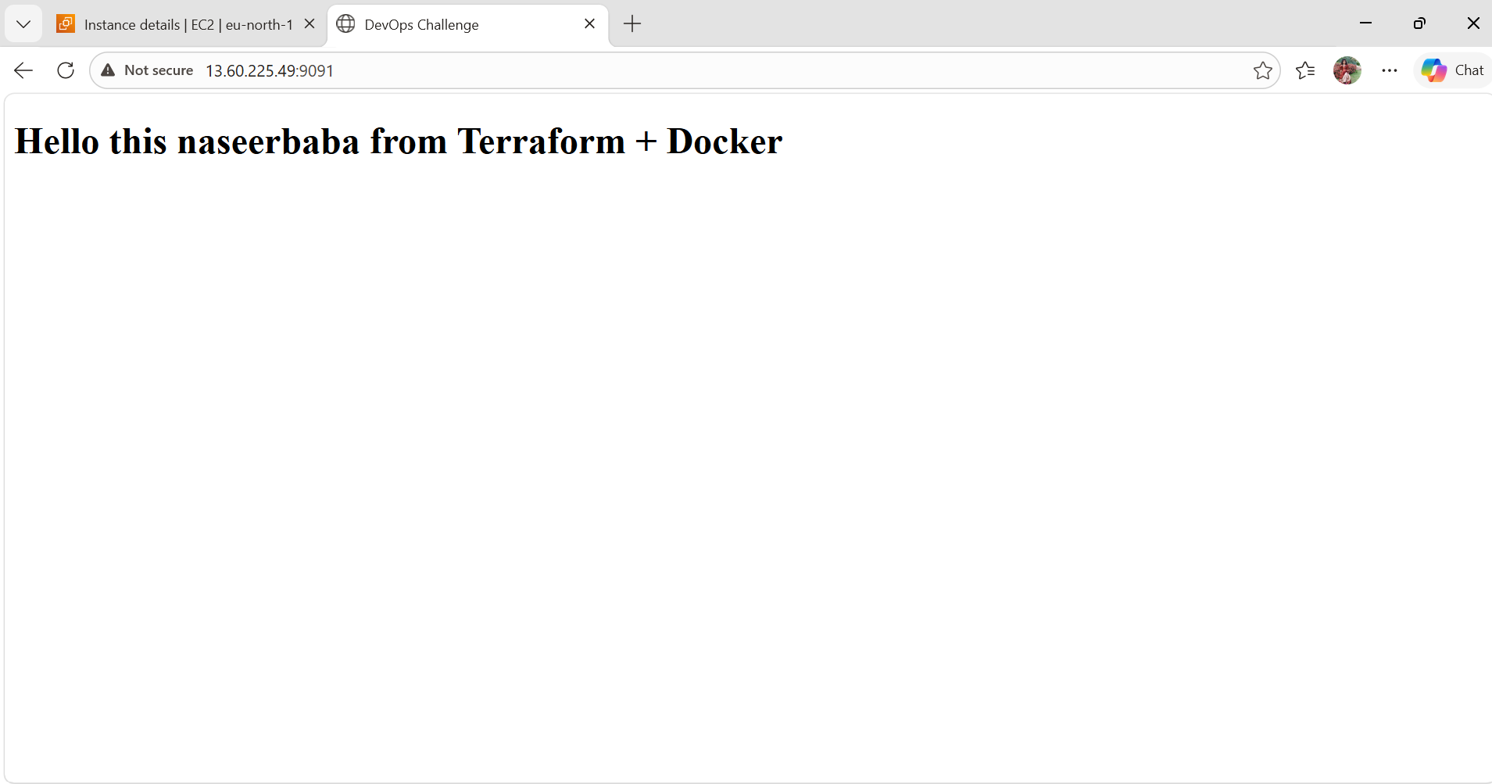

  - Terraform Setup (START FROM HERE)
cd terraform
Now create files:
touch main.tf variables.tf outputs.tf provider.tf terraform.tfvars
Your structure should look like:
project/
├── terraform/
│ ├── main.tf
│ ├── variables.tf
│ ├── outputs.tf
│ ├── provider.tf
│ └── terraform.tfvars
└── scripts/
└── install.sh
  - Provider Configuration
Open provider.tf
provider "aws" {
region = var.region
}
  - Variables
Open variables.tf
variable "region" {
default = "ap-south-1"
}
variable "instance_type" {
default = "t3.micro"
}
variable "key_name" {}
Now open terraform.tfvars
key_name = "your-key-name"
  - Create ECR (Docker Registry)
Open main.tf
resource "aws_ecr_repository" "app_repo" {
name = "myapp-repo"
}
  - Create VPC + Subnet, Security Groups, EC2 SG, EC2 Instance
- Add to main.tf

# VPC
resource "aws_vpc" "main" {
cidr_block = "10.0.0.0/16"
}
# Subnet 1 (Public)
resource "aws_subnet" "public" {
vpc_id = aws_vpc.main.id
cidr_block = "10.0.1.0/24"
availability_zone = "ap-south-1a"
map_public_ip_on_launch = true
}
# Subnet 2 (Public - REQUIRED FOR ALB)
resource "aws_subnet" "public2" {
vpc_id = aws_vpc.main.id
cidr_block = "10.0.2.0/24"
availability_zone = "ap-south-1b"
map_public_ip_on_launch = true
}
# Internet Gateway
resource "aws_internet_gateway" "gw" {
vpc_id = aws_vpc.main.id
}
# Route Table
resource "aws_route_table" "rt" {
vpc_id = aws_vpc.main.id
}
resource "aws_route" "route" {
route_table_id = aws_route_table.rt.id
destination_cidr_block = "0.0.0.0/0"
gateway_id = aws_internet_gateway.gw.id
}
resource "aws_route_table_association" "rta1" {
subnet_id = aws_subnet.public.id
route_table_id = aws_route_table.rt.id
}
resource "aws_route_table_association" "rta2" {
subnet_id = aws_subnet.public2.id
route_table_id = aws_route_table.rt.id
}
# SECURITY GROUP - Load Balancer
resource "aws_security_group" "lb_sg" {
vpc_id = aws_vpc.main.id
ingress {
from_port = 80
to_port = 80
protocol = "tcp"
cidr_blocks = ["0.0.0.0/0"]
}
egress {
from_port = 0
to_port = 0
protocol = "-1"
cidr_blocks = ["0.0.0.0/0"]
}
}
# SECURITY GROUP - EC2
resource "aws_security_group" "ec2_sg" {
vpc_id = aws_vpc.main.id
# Only LB → EC2
ingress {
from_port = 80
to_port = 80
protocol = "tcp"
security_groups = [aws_security_group.lb_sg.id]
}
# SSH (for testing)
ingress {
from_port = 22
to_port = 22
protocol = "tcp"
cidr_blocks = ["0.0.0.0/0"]
}
egress {
from_port = 0
to_port = 0
protocol = "-1"
cidr_blocks = ["0.0.0.0/0"]
}
}
# EC2 INSTANCE
resource "aws_instance" "app" {
ami = "ami-0a0823e4ea064404d"
instance_type = var.instance_type
subnet_id = aws_subnet.public.id
key_name = var.key_name
vpc_security_group_ids = [aws_security_group.ec2_sg.id]
user_data = file("../scripts/install.sh")
tags = {
Name = "DevOps-App"
}
}
# LOAD BALANCER (FIXED)
resource "aws_lb" "app_lb" {
name = "app-lb"
load_balancer_type = "application"
subnets = [
aws_subnet.public.id,
aws_subnet.public2.id
]
security_groups = [aws_security_group.lb_sg.id]
}
# TARGET GROUP
resource "aws_lb_target_group" "tg" {
port = 80
protocol = "HTTP"
vpc_id = aws_vpc.main.id
}
# ATTACH EC2
resource "aws_lb_target_group_attachment" "attach" {
target_group_arn = aws_lb_target_group.tg.arn
target_id = aws_instance.app.id
port = 80
}
# LISTENER
resource "aws_lb_listener" "listener" {
load_balancer_arn = aws_lb.app_lb.arn
port = 80
protocol = "HTTP"
default_action {
type = "forward"
target_group_arn = aws_lb_target_group.tg.arn
}
}
user_data = file("../scripts/install.sh")
tags = {
Name = "DevOps-App"
}
}
  - User Data Script
cd ../scripts
vi install.sh
Go to scripts/install.sh
#!/bin/bash
yum update -y
yum install -y docker
systemctl start docker
systemctl enable docker
# Add ec2-user to docker group
usermod -aG docker ec2-user
docker pull nginx
# Run container
docker run -d -p 80:80 nginx
#Give permission
chmod +x install.sh
  - Output
Vi outputs.tf
output "lb_dns" {
value = aws_lb.app_lb.dns_name
}
This gives your app URL
  - Key Pair
Run this:
ssh-keygen -t rsa
Upload .pub key in AWS
ls ~/.ssh
cat ~/.ssh/id_rsa.pub
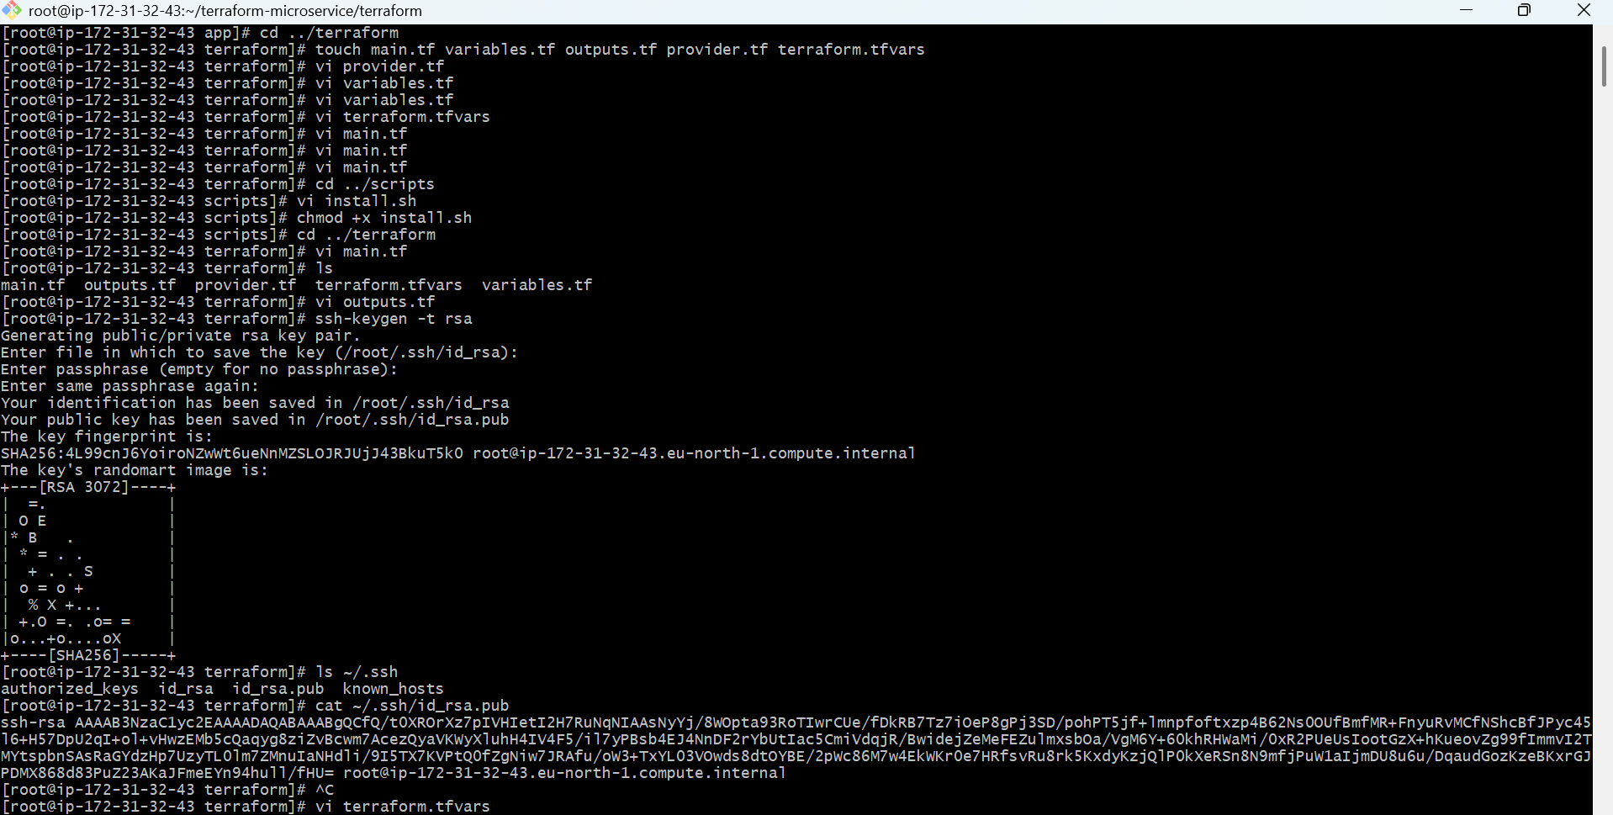
  - Open AWS Console
Go to https://console.aws.amazon.com
Login Go to EC2 Dashboard On left side menuClick “Key Pairs”Import Key Pair
STEP 6: Fill Details
Key pair name: my-key
Key pair type
Keep default: RSA
Paste what you copied:
ssh-rsa AAAAB3NzaC1yc2EAAAADAQABAAABAQC...
Click Import
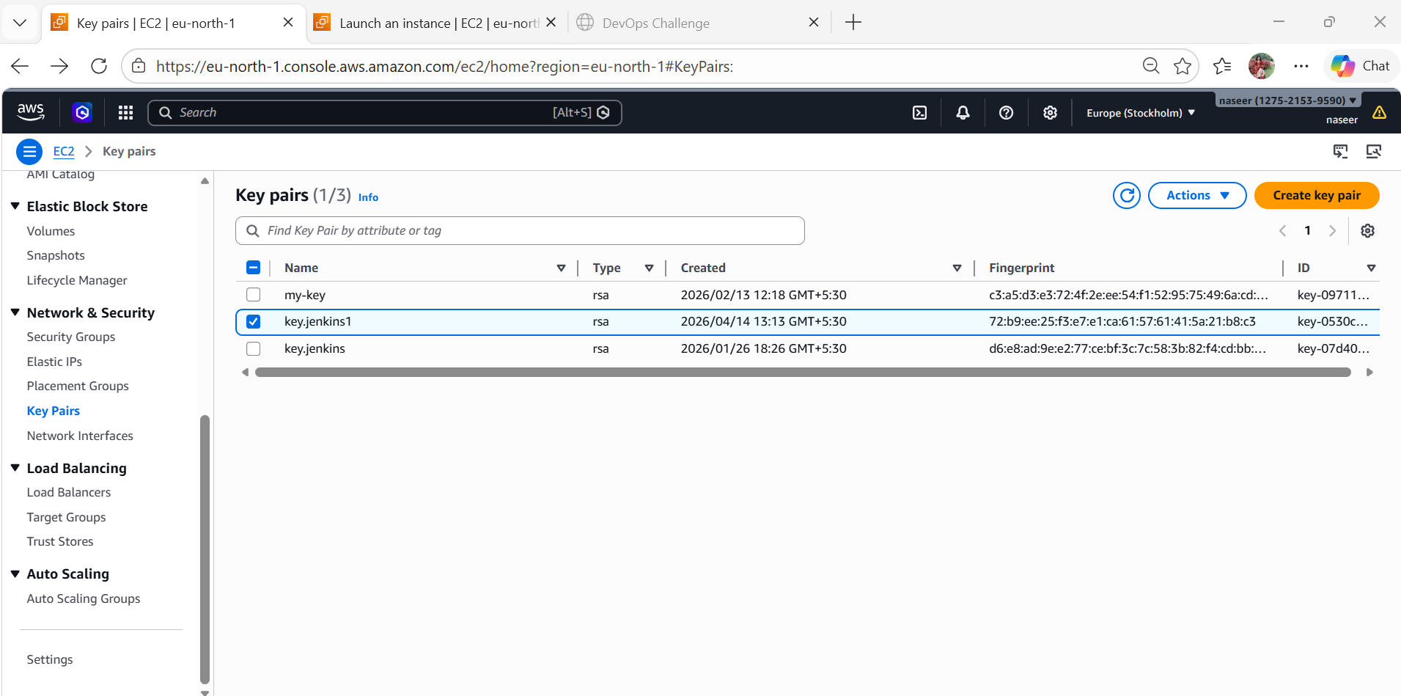
  - CONNECT WITH TERRAFORM
Open: vi terraform.tfvars
Add: key_name = "my-key"
HOW YOU WILL LOGIN LATER
ssh -i ~/.ssh/id_rsa ec2-user@<EC2-IP>
  - Terraform Commands
terraform init
terraform plan
terraform apply
Type yes
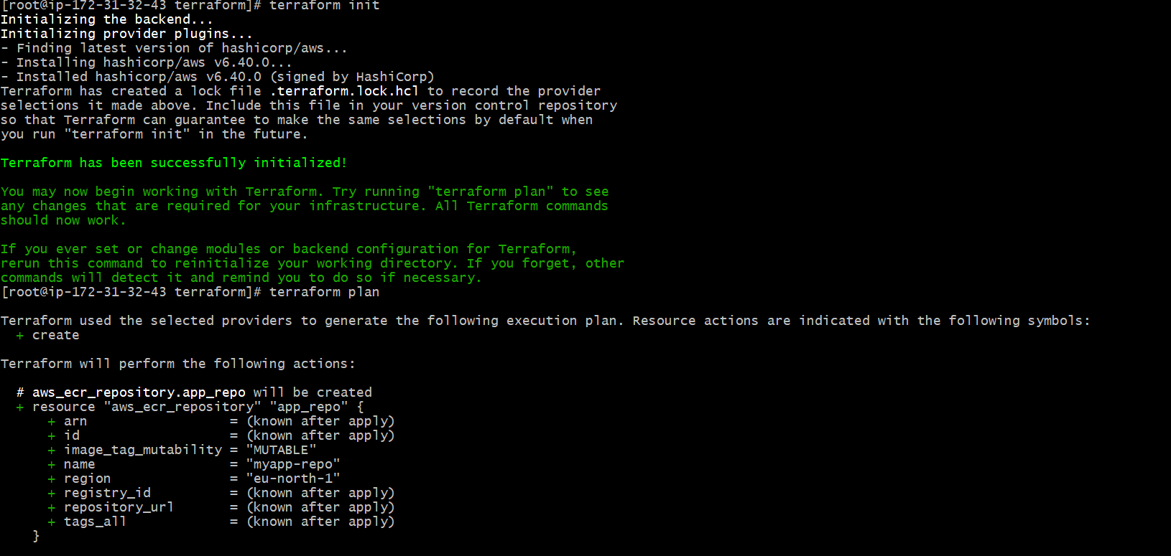
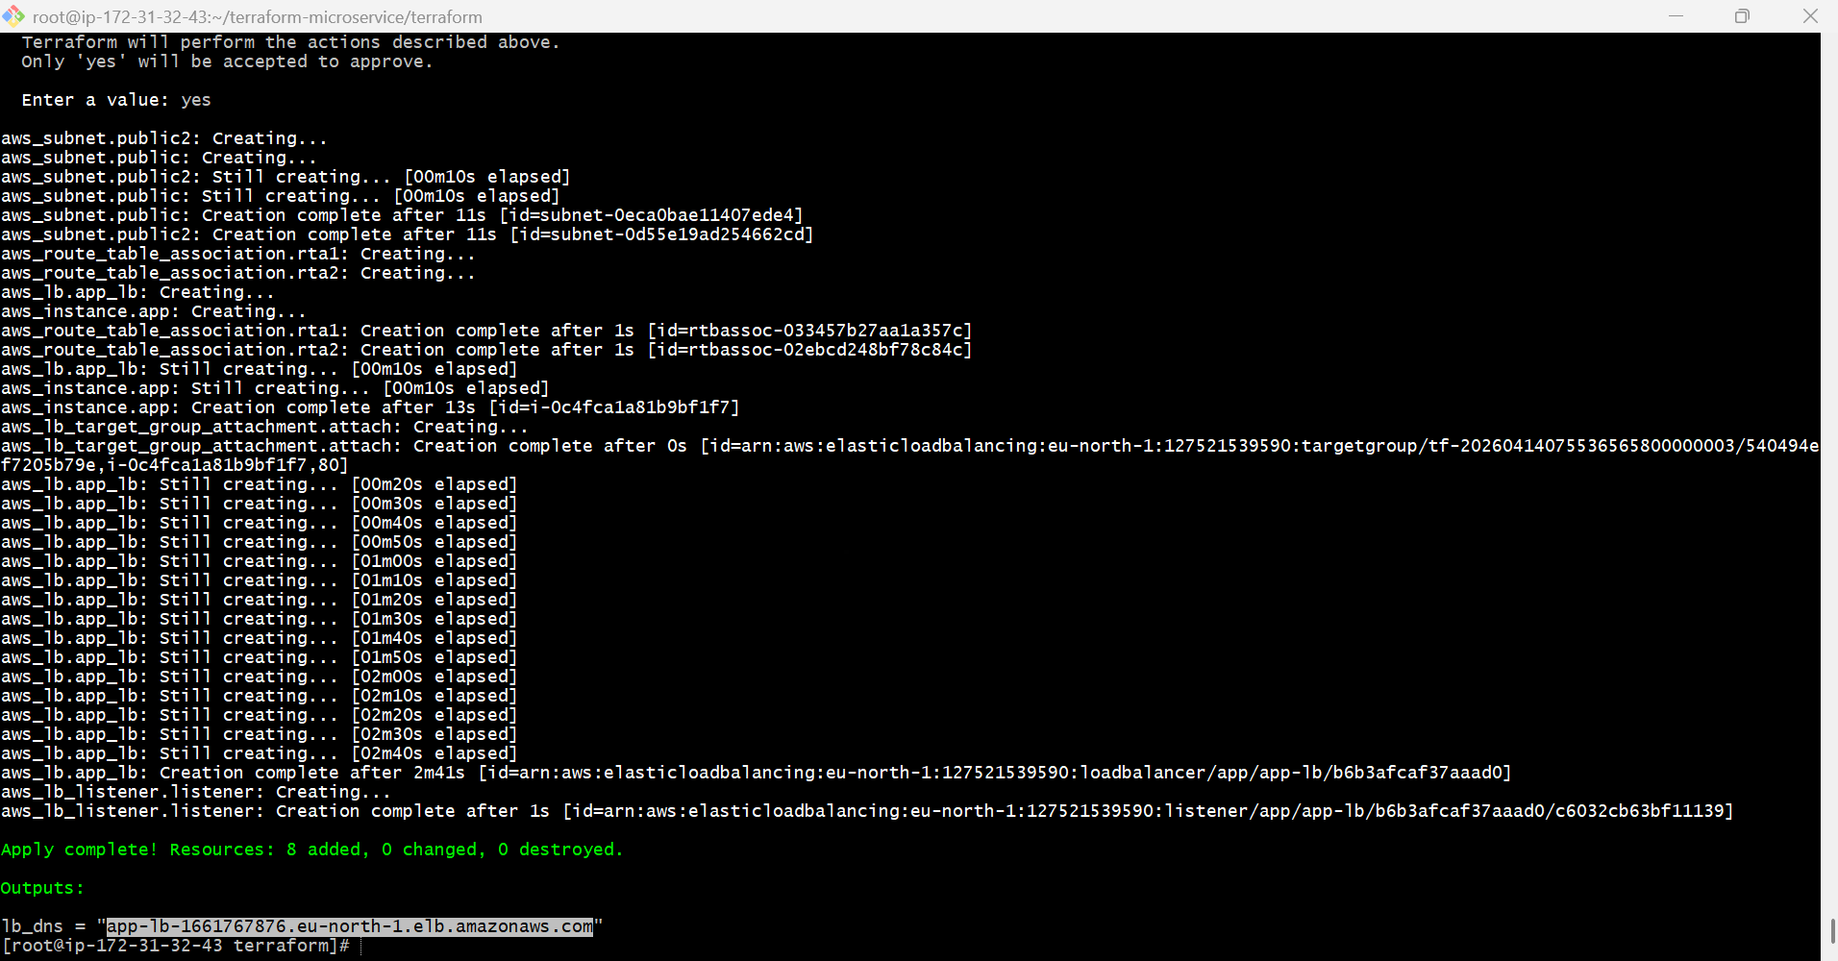
Terraform will:
- Create VPC
- Create EC2
- Create LB
- Connect everything
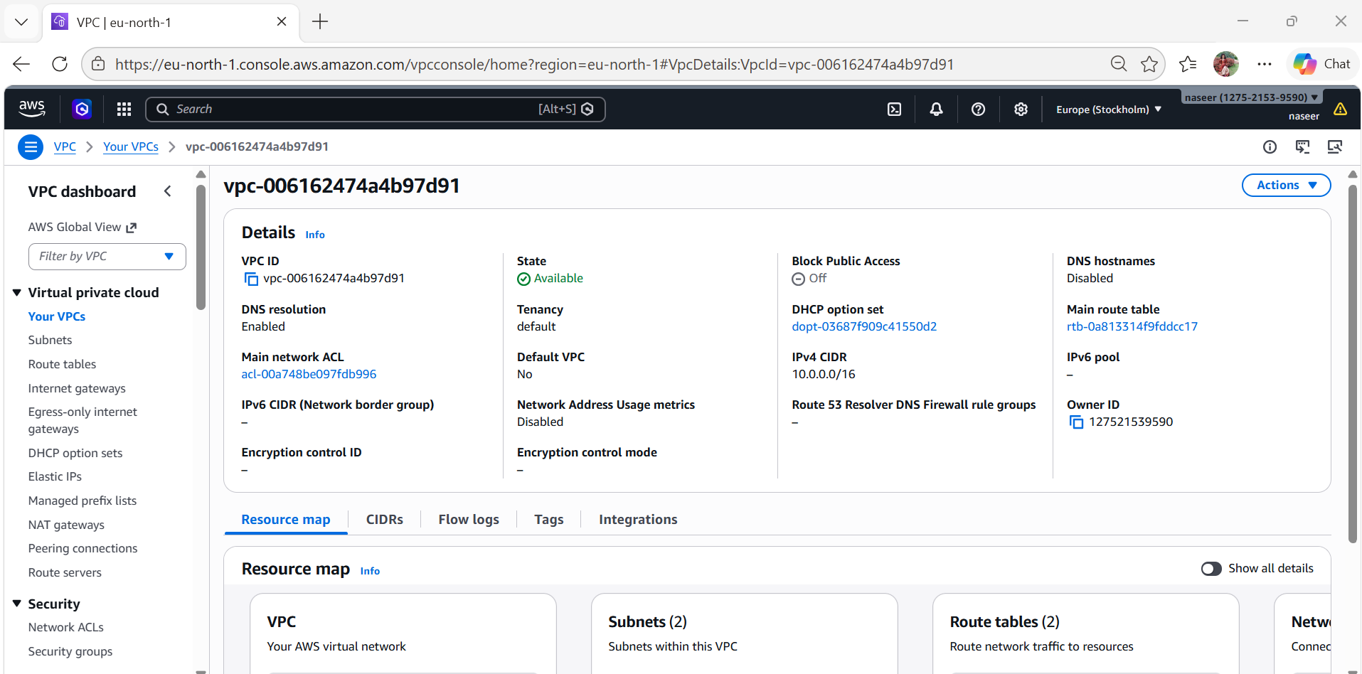
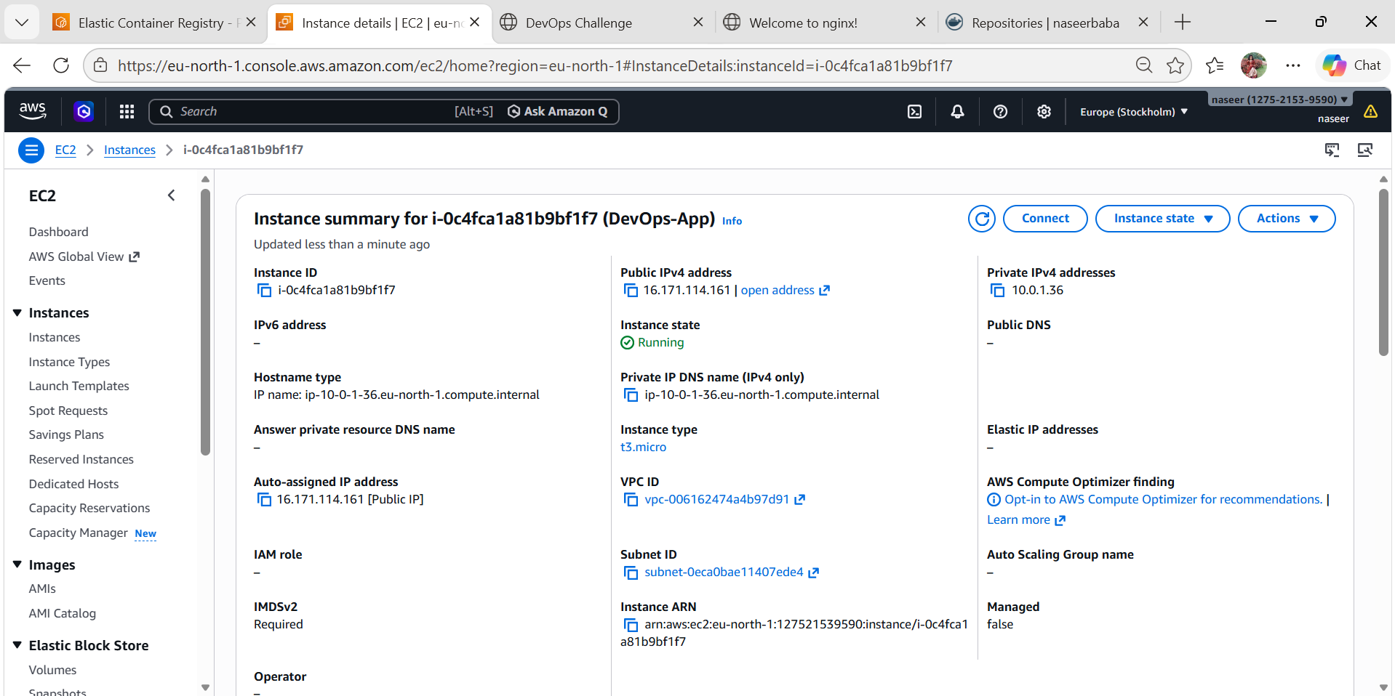

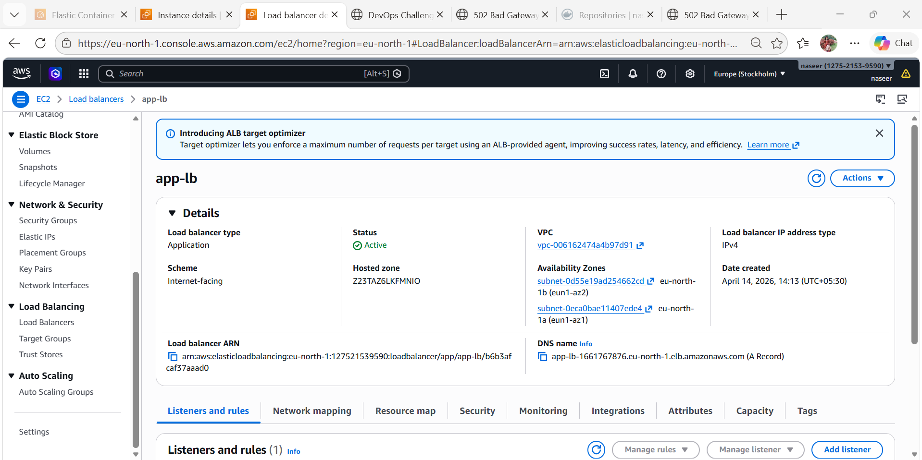

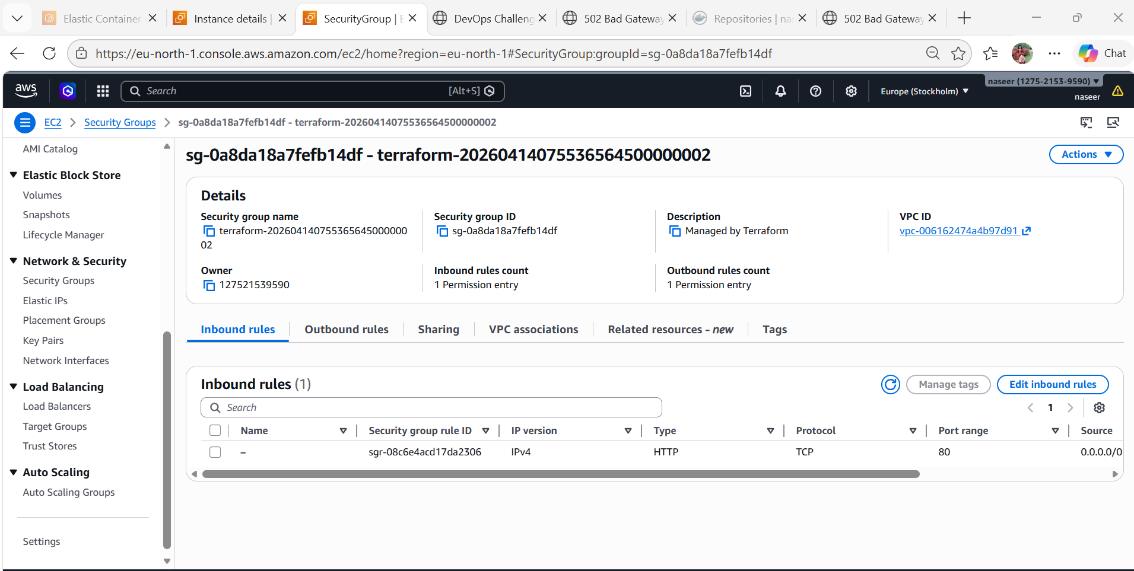

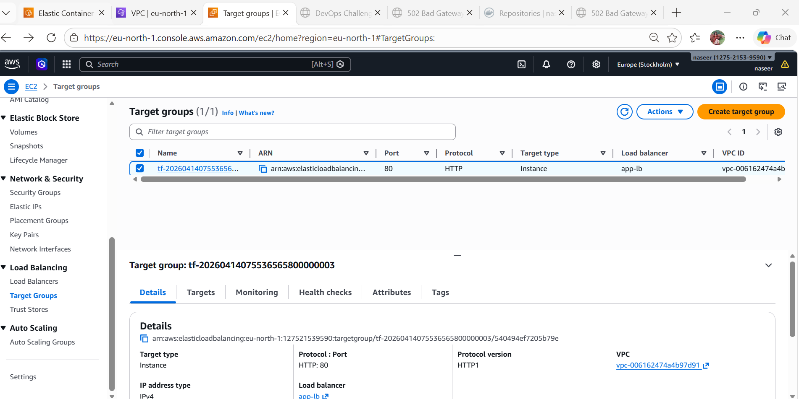
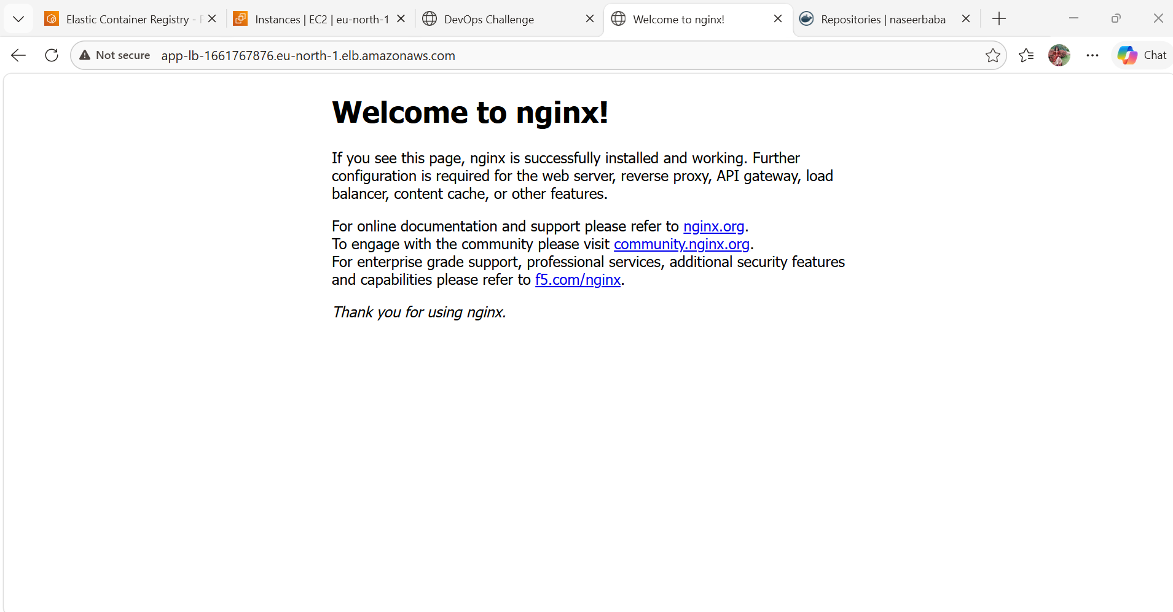
  - Push Docker Image to ECR
aws ecr get-login-password --region eu-north-1 | \
docker login --username AWS --password-stdin 127521539590.dkr.ecr.eu-north-1.amazonaws.com
docker tag myapp:latest 127521539590.dkr.ecr.eu-north-1.amazonaws.com/myapp-repo:latest
docker push 127521539590.dkr.ecr.eu-north-1.amazonaws.com/myapp-repo:latest
